SAGES 2015 Nonprofit Preference Assignment

Learning is best when it is personalized, engaging your interests.

For the Nonprofit Analysis Project it will be most helpful if you look at a nonprofit in an area in which you have some interest. Since you will need to spend time at the nonprofit organization, and interview several or the people involved, you are restricted to nonprofits operating in the Cleveland area. In addition, the nonprofit will need to also fulfill these requirements:

- The organization must file a 990 form on Guidestar. Therefore, it cannot be either a small organization or one that is classified as a church, and therefore does not have to file with the Internal Revenue Service.
- The organization must:
  - Use Form 990, and not 990-EZ or 990 PF
  - Be a 501(c)3 organization
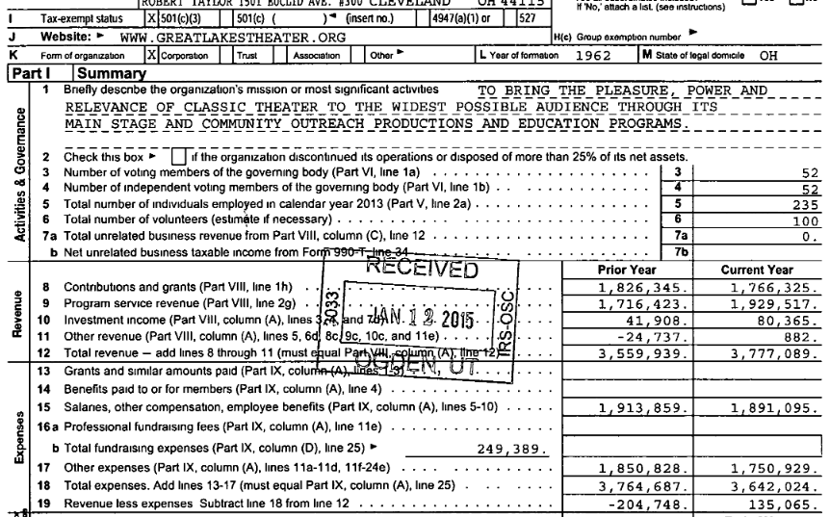

  - Have at least $2 million in expenses.
- The organization must have at least 3 full years of 990s filed on Guidestar.
- You will have a more fruitful experience if you select a medium size nonprofit – one large enough to be substantial, but not so large that you’ll have a difficult time understand it in all its complexity.
So, in selecting a nonprofit organization for your project, follow these guidelines:

- Decide which nonprofit area you are interested in studying. Areas, and examples of nonprofits, include:
- Education: Private elementary or secondary schools; private universities.
- Youth Development: Scouts; Big Brothers, Big Sisters; Boys and Girls Clubs; afterschool programs; mentoring programs; etc.
- Health: Hospitals; Clinics; Mental Health Agencies; Substance Abuse Programs
- Homeless: Shelters; Transitional Housing programs; Outreach programs.
- Job Training and Services:

Guidestar lists over 5,000 nonprofit organization in Cleveland alone, not including the surrounding areas! The type of nonprofits you may research include these. You will write the broad, as well as the sub-category, under “Type of Nonprofit” in your assignment.

- Arts, Culture and Humanities
  - Humanities and Historical Societies
  - Media
  - Museums
  - Performing Arts
  - Service and Other
- Education and Research
  - Colleges and Universities
  - Elementary and Secondary
  - Libraries
  - Research Institutes
  - Service and Other
  - Vocational, Technical and Adult
- Environment and Animal
  - Animal Protection, Welfare and Services
  - Beautification and Horticulture
  - Conservation and Environmental Education
  - Health Care Facilities and Programs
  - Pollution
  - Service and Other
  - Zoos and Veterinary Services
- Health
  - Addiction and Substance Abuse
  - Diseases and Disease Research
  - Health Care Facilities and Programs
  - Medical Disciplines and Specialty Research
  - Mental Health and Crisis Services
- Human Services
  - Agriculture, Food and Nutrition
  - Crime and Legal Related
  - Employment and Occupations
  - General Human Services
  - Housing
  - Public Safety, Disaster Preparedness, and Rescue
  - Recreation and Sports
  - Youth Development
- International

You will turn in your nonprofit assignment on Thursday, September 10. If I do not receive this on time, I will assign you to a nonprofit.
SAGES 2015 Nonprofit Preference Assignment
You only need to turn in this page!

Name: Jacob Alspaw jaa134

First Choice for Type of Nonprofits: [i.e. Education] (3 points)
Write the type of nonprofit here:
Human Services

 | Then list 3 area nonprofits of that type in the Cleveland area that meet these criteria: (4 points each)
1 | Ronald McDonald House of Cleveland, Inc.
2 | Cleveland Sight Center
3 | Mental Health Services For Homeless Persons
Second Choice for Type of Nonprofits: [ i.e. Homeless] (3 points)
Write the type of nonprofit here:
Health

 | Then list 3 area nonprofits of that type in the Cleveland area that meet these criteria: (4 points each)
1 | Free Medical Clinic of Greater Cleveland
2 | Northern Ohio Recovery Clinic
3 | Community Action Against Addiction

Please note: You are researching and selecting six individual nonprofit organizations, not simply listing nonprofit subcategories!

